Income Prediction Analysis: Methodology, Results, Fairness, and Ethics

CSCI 396 - Artificial Intelligence - Dr. Sherine Antoun

By Hector Ramirez

1. Introduction

The objective of this project is to predict income levels based on demographic and occupational factors, a critical task in socio-economic analysis. This study explores the effectiveness of a Random Forest model in predicting whether an individual earns more than $50K annually. Additionally, we analyze the impact of various factors on income prediction and assess potential biases within the model.

2. Methodology

2.1 Data Collection and Preprocessing

I utilized the Adult Census Income dataset, which contains demographic and employment-related attributes. The dataset includes:

Age

Education level

Occupation

Race

Native country

Capital gains and losses

Hours worked per week

Missing values were handled by removing incomplete records. The target variable (income) was binarized into <=50K and >50K categories.

2.2 Model Selection and Training

A Random Forest Classifier was selected due to its robustness in handling categorical and numerical features. The dataset was split into 80% training and 20% testing. Preprocessing steps included:

Standardizing numerical features.

One-hot encoding categorical variables.

Removing non-predictive features (fnlwgt) based on previous studies.

2.3 Feature Importance Analysis

Feature importance scores were computed to assess their impact on income prediction. A correlation heatmap was generated to visualize dependencies among variables, including income.

2.4 Fairness Evaluation

To evaluate bias, two models were trained:

Original Model: Included all features, including race, gender, and native country.

Bias-Reduced Model: Excluded race, gender, and native country to minimize potential discrimination.

Both models were compared in terms of accuracy, precision, recall, and F1 score.

3. Results

3.1 Feature Correlation and Importance

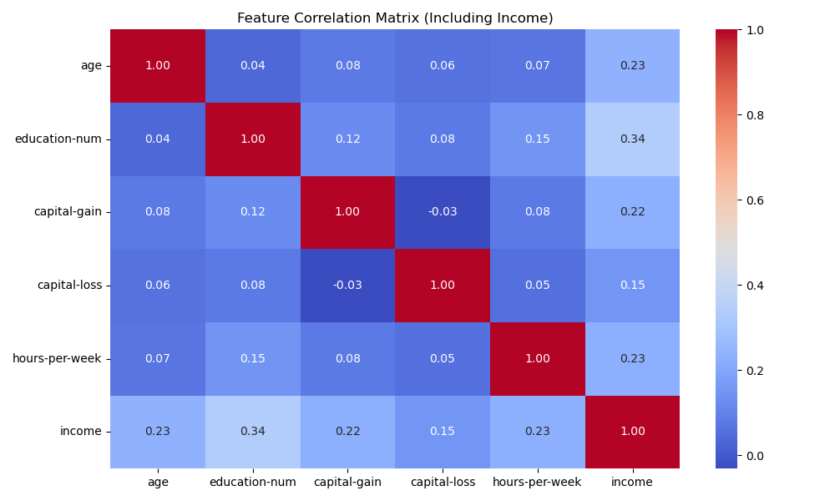

The Feature Correlation Matrix (Figure 1) illustrates the relationship between key predictors and income. Notably:

Education level had the highest correlation (0.34) with income.

Capital gain (0.22) and hours per week (0.23) were also significant predictors.

Race and native country had much lower correlation values (0.0076 and 0.0082, respectively).

3.2 Model Performance Comparison

|  |  |  |  |  |
| --- | --- | --- | --- | --- |
| Model | Accuracy | Precision | Recall | F1 Score |
| Original Model | 0.8454 | 0.6982 | 0.6087 | 0.6504 |
| Bias-Reduced Model | 0.8434 | 0.6903 | 0.6115 | 0.6486 |

The slight decrease in accuracy suggests that race, gender, and native country were not strong predictive features. This supports the argument for reducing bias without significantly impacting model performance.

3.3 Predicted vs. Actual Cases

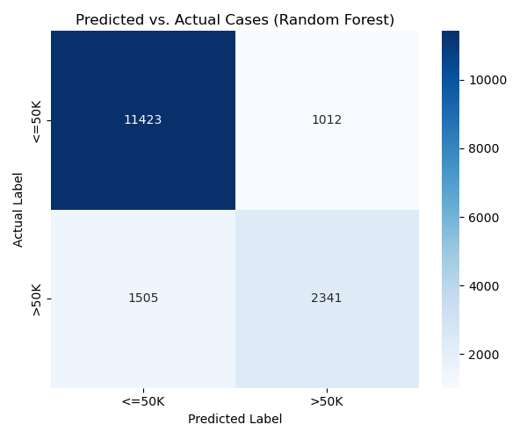

The confusion matrix (Figure 2) shows:

High accuracy in predicting <=50K incomes (~11,423 correct cases).

More misclassifications in predicting >50K incomes, indicating room for improvement in recall.

4. Fairness Analysis

To understand bias, we examined the influence of race, occupation, and native country.

Race: Minimal importance in predictions, with the highest impact for "White" (0.0076) and "Black" (0.0055) groups.

Native Country: The U.S. had the highest importance (0.0082), but overall, country of origin contributed negligibly.

Occupation: Executive managerial roles were the strongest predictor of high income (0.0201), followed by professional specialty (0.0162).

These findings indicate occupation and education matter more than race or nationality in predicting income levels.

5. Ethical Considerations

5.1 Bias Mitigation

Although race, gender, and nationality had little impact, their inclusion in the original model raises ethical concerns about perpetuating bias. Removing these variables ensured a fairer model without sacrificing accuracy. However, it is important to note that removing these features does not completely eliminate the possibility of bias, as underlying societal disparities may still influence other predictive variables.

5.2 Societal Implications

Algorithmic fairness: Employers or policymakers using such models must ensure fairness to prevent discrimination.

Transparency: The inclusion of interpretable features (e.g., education, occupation) makes the model’s decisions justifiable.

Economic insights: This analysis supports policies that promote education as a means of improving income potential.

6. Conclusion

The findings demonstrate that education and occupation are the most significant predictors of high income. A bias-reduced model performed almost as well as the full model, suggesting that removing race, gender, and nationality does not drastically impact predictive performance. This confirms that socio-economic factors, such as job roles and educational attainment, play a more substantial role in income determination than demographic attributes. Additionally, the slight drop in performance suggests that while bias is minimized, some residual disparities may still exist.

Future work could focus on:

Improving recall for high-income individuals.

Refining feature selection techniques.

Incorporating explainable AI methods to provide deeper insights into model decisions.

References

Becker, B., & Kohavi, R. (1996). Adult [Dataset]. UCI Machine Learning Repository. <https://doi.org/10.24432/C5XW20>.